Question1:
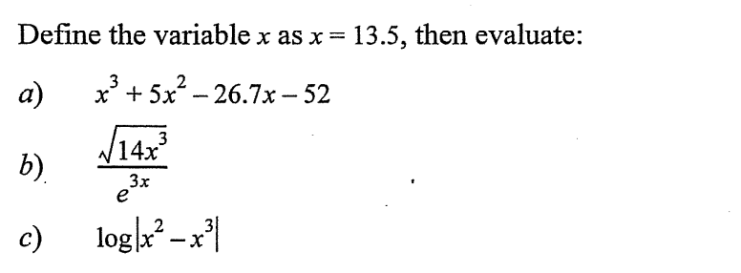

Answer1:
a) x=13.5
x^3+5*x^2-26.7*x-52
b) sqrt((14*x^3))/exp(3*x)
c) log(abs(x^2-x^3))

Question2:
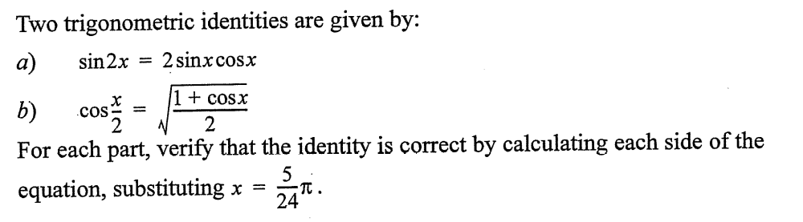

Answer2:
a) x=5/24*pi
LHS=sin(2*x)
RHS=2*sin(x)*cos(x)
b) LHS=cos(x/2)
RHS=sqrt((1+cos(x))/2)

Question3:
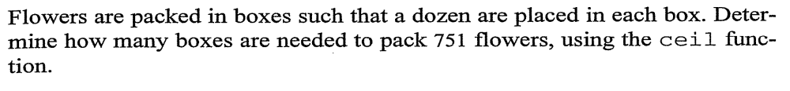
Answer3:
ceil(751/12) = 63

Question4:
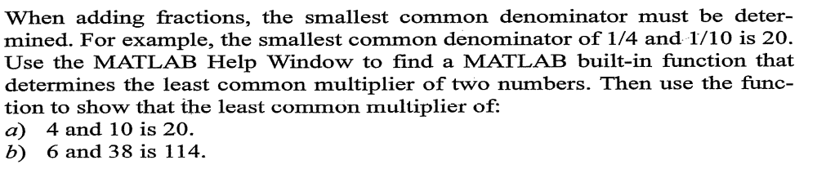
Answer4:
a) lcm(4,10)

b) lcm(6,38)

Question5:
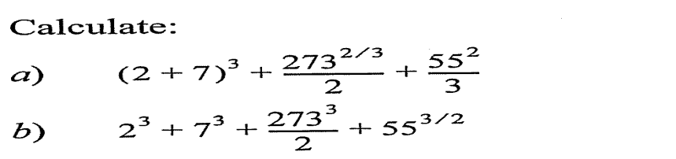

a) ((2+7)^3)+(273^(2/3))/2+(55^2)/3

b) 2^3+7^3+(273^3)/2+(55^(3/2))

